**Challenge 1 - devhack**

Use the values obtained from below to find the flag.

a= (ABCD1110)decimal

Why don’t you try lighting up the bulb ? ;-)

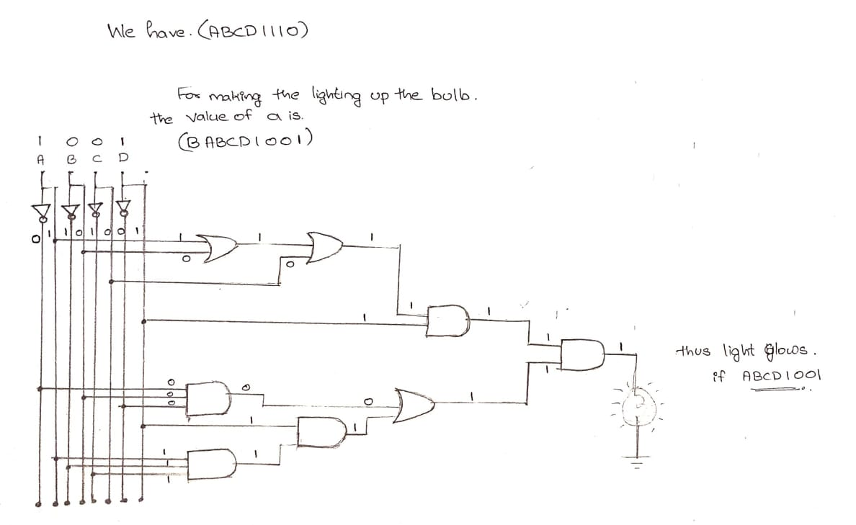

b= (EBXACDYZ)decimal

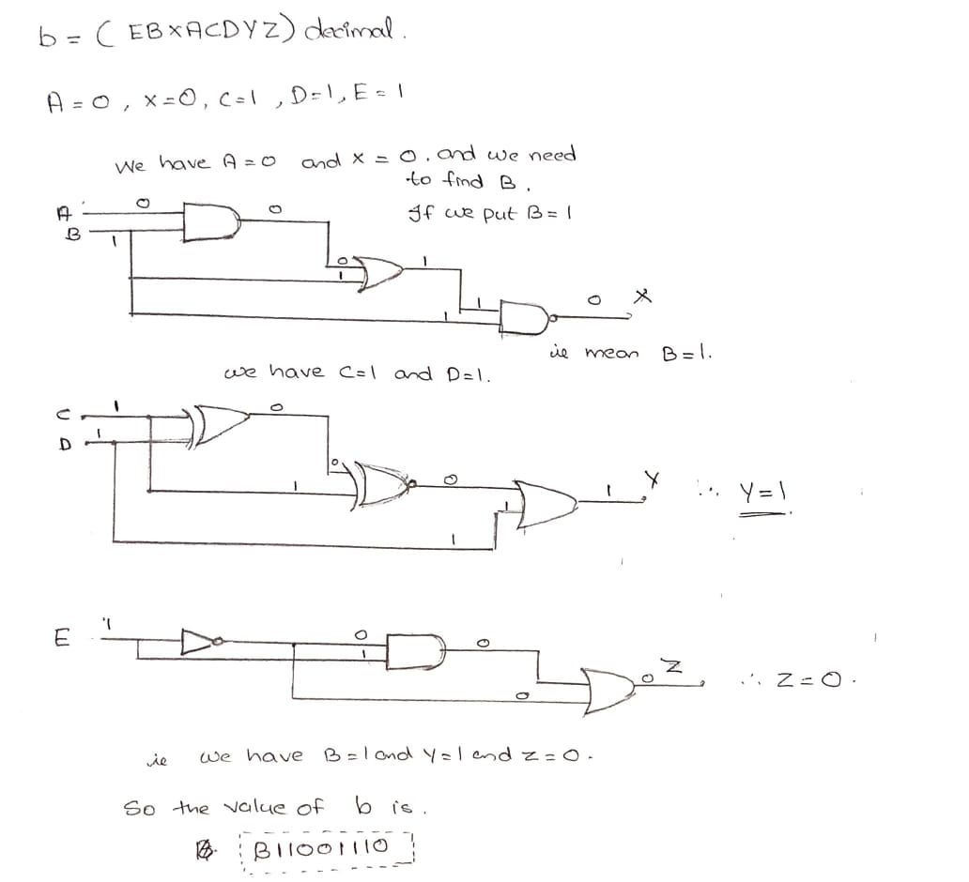

Go to the link given below and find a way to use the above values obtained and get the flag.

Hint : Try using the Serial monitor

[**circuit-simulation**](https://www.tinkercad.com/things/i4zM833ITGZ)

FLAG format : flag{--flag goes here--}

**Screen Shot** of the Simulation of FLAG

As first we need to enter the users name as input after that it as the for the value a and b that we get from solving the above two problems recpectievely.After that we need to Input the value a which is (B1001) and the value of b which is (B11001110).

After inputing the value we get FLAG= in the 7 Segment display.

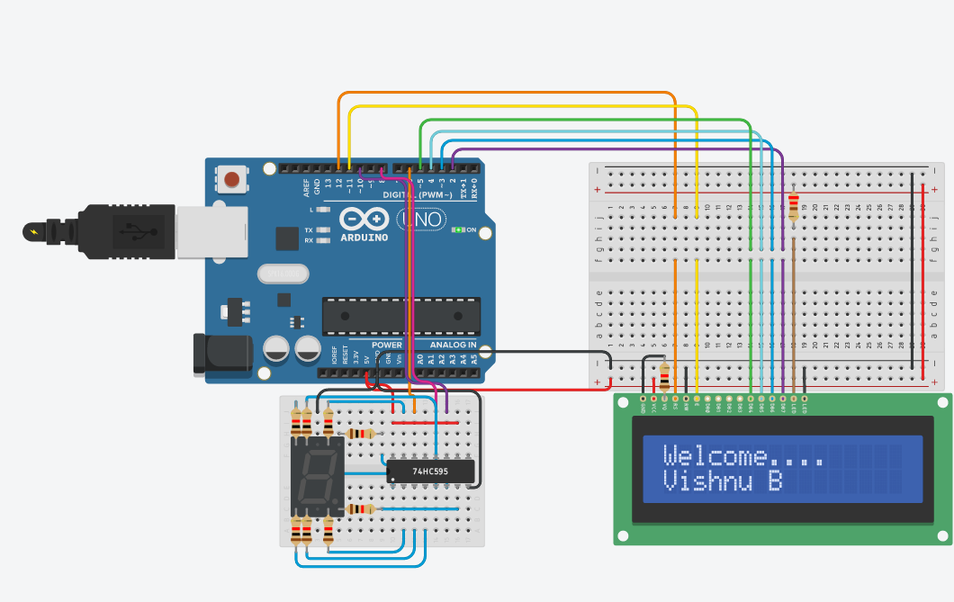

THE SERIAL MONITOR INPUT SCREENSHOT

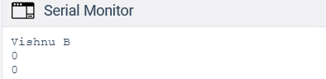

THE SCREENSHOT OF THE WORD FLAG=

